U.S. consumer prices push higher; high unemployment likely to keep the lid on inflation
Source: https://www.reuters.com/article/us-usa-economy-idUSKCN2581SA
Date of Article: 12th August 2020
Date Written: 29th March 2021
Word count: 1068
Section: Macroeconomics

Definition:
- Equilibrium: The equilibrium happens when the demand and supply on the market reach an equal point, the point that the demand curve and supply curve cross each other.
- Inflation: Inflation is the rate that indicates the general increase in the price of goods or services in an economy over time.
- Unemployment rate: The unemployment rate is the rate that indicates the percentage of unemployed workers in the total labor force who are older than 16.
- Demand-pull inflation: The increase in the price of goods or services in an economy caused by the supply shortage, which means the total demand exceeds the total supply.
- Phillips curve: Phillips curve is an economic concept that indicates the relationship between the inflation rate and the unemployment rate.

Suppose that the economy can be illustrated by the graph below
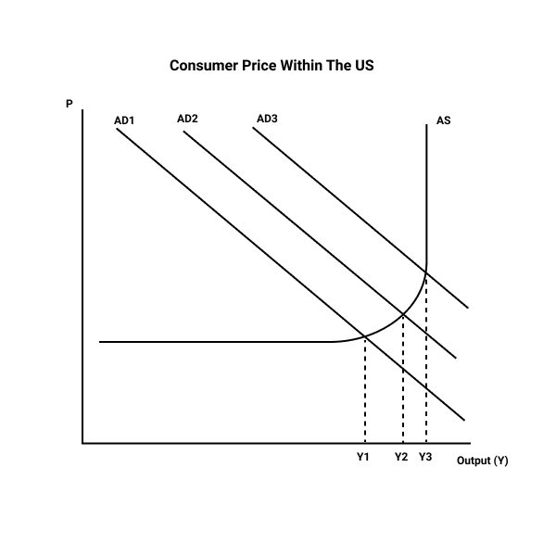

Recall, from the quantity theory of money, M * V = P* Q where
M is the money supply
V= velocity of money
P= price level (inflation)
Q = Real growth in GDP.
The aggregate demand curve is derived from this identity matrix that formed the monetarist school of thought's basic tenet. According to them, the general price increase is everywhere a monetary phenomenon, and in the long run, money is neutral. The AD curve slope is negative, implying an inverse relationship in growth in price and real GDP. Any random point on the curve gives a nominal GDP (combination of inflation and Real GDP) sufficient for a given level of spending.
At a low inflation rate, the Fed buys Treasury bills and notes from the commercial banks, which build up their reserves. The banks can provide more loans to the market players through the fractional reserve system, thus increasing the money supply and drives the interest rates low so that production increases.
At a higher inflation rate, the Fed reduces the money supply by selling T-bills and notes tightening the liquidity. The markets for loanable funds respond by increasing interest rates cutting down on production. These monetary policy tools shift the AD curve to the desired level.

The Aggregate Supply curve
The aggregate supply curve has a positive relationship between output and prices, serving the capitalist and entrepreneurs who are profit maximizers. As the output increases, resources such as land, labor, and capital are highly utilized and scarce with every increasing output. At full employment level Y₁, Solow's aggregate supply curve is vertical, and any attempt to increase aggregate demand would only result in higher prices. It would be therefore profitable to leave the economy free from any expansionary policy.
Unlike the aggregate demand curve, AS is not linear. At low production levels, the economy has a high unemployment rate of resources, and therefore it's cheaper to start a business, rising marginally. As the economy gains momentum, it becomes expensive to start a business as unemployment rapidly falls.

At equilibrium
If the economy is operating below the full employment level producing the Y₁ level of output, the government can use discretionary fiscal and monetary policies to stimulate the aggregate demand.
Monetary policy tools
During a recession, aggregate demand is falling due to a fall in household incomes. The reasonable growth rate is deprived of the optimum mix of human resources and capital as the investment demand falls. Inventories are increasing, and prices are rising. Suppliers cut down their production capacities laying off more workers amplifying the initial negative demand shock. Fall in production shifts the short-run aggregate supply curve to the left, causing a decline in real output.
At the Y₁ level of output, the economy is at full employment level. At this level, there is no cyclical unemployment.

Fiscal policy tools
Alternatively, the government may use expansionary fiscal policy to increase government spending or effect a tax cut.

Policy implications of a tax cut
A reduction in the tax rate for individual and or business income has different policy ramifications from consumers' viewpoint. A fall in tax, when perceived temporary, would cause no changes in the AD curve simply because taxpayers may opt to save the money instead of spending following the Ricardian equivalence that postulates that rational taxpayers would save a tax cut from offsetting against the future increase in taxes. Consumer saving income from the tax cut would not help the economy rise from a recession; however, if the taxpayer perceives the tax cut as permanent, consumption spending shifting the AD curve outwards.
A tax cut would increase real GDP from the fiscal multiplier but at a slower rate due to the marginal propensity to consume than would a direct increase in government spending on an infrastructural project, implying that increasing government spending is more effective than a tax cut.
Despite the fiscal policies challenges of timeliness, targeting, and economists mostly prefer implementation lag, an increase in government spending because it targets the unemployed. Unlike a tax cut that increases the employed population's disposable income, the unemployed in the labor force also affected by a recession can access income. The Fed targets the jobless during a downturn because they have a low opportunity cost than the employed. These unemployed people could have been previously active in the labor market but laid off following a fall in production, adding to those actively looking for a job, thereby raising the unemployment rate.

However, a policy intervention of increasing aggregate demand through an increase in government income seems to be the only viable option of reducing unemployment but at the cost of inflation. From the AD-AS model, every increase in AD is followed by the rise in real output and higher inflation. The rise in RGDP means that firms are expanding their production capacities and are therefore employing more workers. This indirect relationship between the price level and the unemployment rate is represented by the Phillips curve, as shown below.

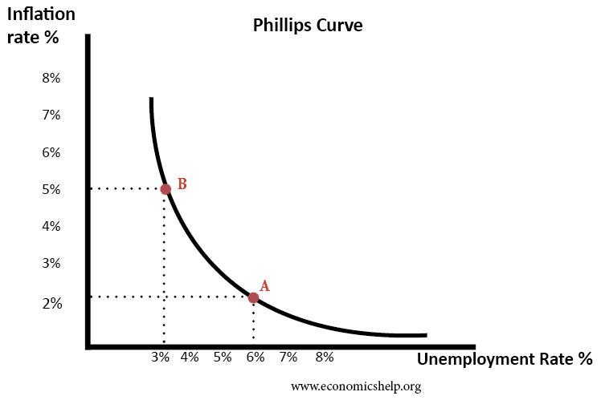
Suppose the rate of inflation in the economy was 2%, the corresponding unemployment rate would be 6%. As the general price level rises to 5%, the unemployment level falls to 3%. Therefore, the Phillips curve shows a trade-off between the inflation rate and the unemployment rate. Any expansionary fiscal policy results in a lower rate of unemployment at the cost of higher inflation.

